Setting is where the characters are.

Setting

Do your surroundings change? Do they influence your decisions?

Setting is often part of the EXPOSITION: the who, what, where, why: the backstory, it ‘sets the scene” for the rest of the story.

Setting puts the story in context. The setting is one literary device that informs the theme.

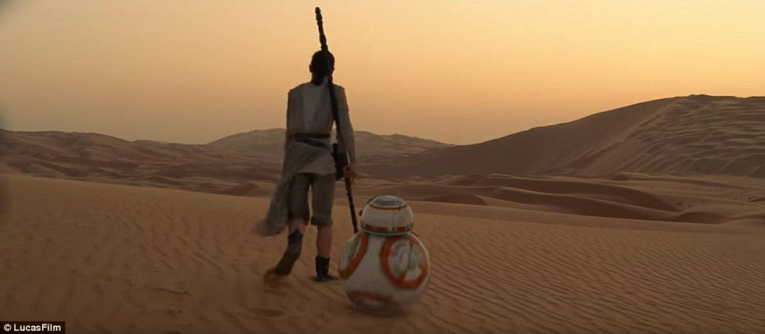

Characters:

Characters are the emotional energy of a story.

What is happening in your own narrative?

Characters

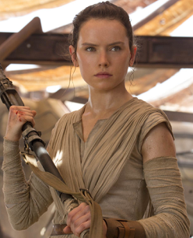

Characters are the psychological force of the story: the emotions, decisions, and ethics. The protagonists and antagonists.

Characters show and tell us who they are. The characters are one literary device that informs the theme.

Point of View:

Point of View

Understanding different points of view, or who is telling the story, tells us critical information.

Point of view is who is telling the story: first, second, third person?

POV is one literary device that informs the theme.

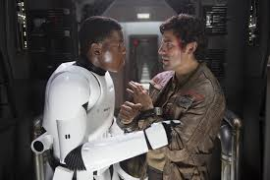

Conflict:

Life is conflict. How the story plays out, (the plot) and how we respond (the characters) in the situation we’re in (the setting) leads us to resolutions.

Conflict

There are often multiple conflicts in any story, narrative or information. Getting at the heart of what the characters want is essential to naming the conflict. There is no story without a conflict. It’s just a grocery list.

Understanding the conflicts is critical to theorizing about themes. One might say the conflicts are the themes.

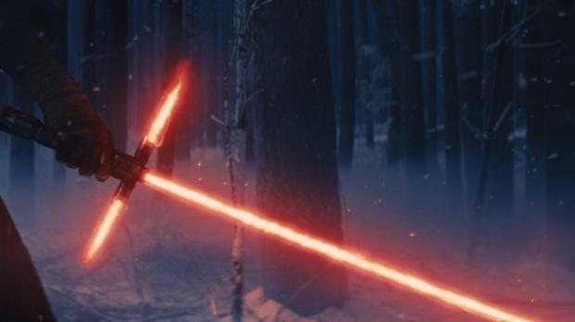

Plot:

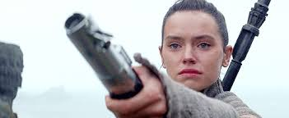

How did the story change?

Themes are the big questions and we are seeking answers. We are the reader, writer, and our own understandings and perspectives.

Theme

Remember there may be multiple themes.

A theme is not a topic.

A theme is an exploration, a question, and ideas.

Themes are big messages.

Resolution is the response to the conflict. BUT: it does not always mean it’s a ‘happy ending.’

Resolution

There are mulitple ways to resolve conflicts, and some lead to a better outcome and some lead to worse. This question of how is the conflict resolved often has us asking more questions.

The resolution tells us what the author believes about the theme and message of the story. Pay attention.

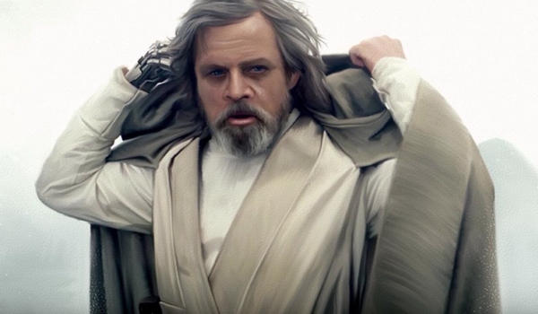

Theme:

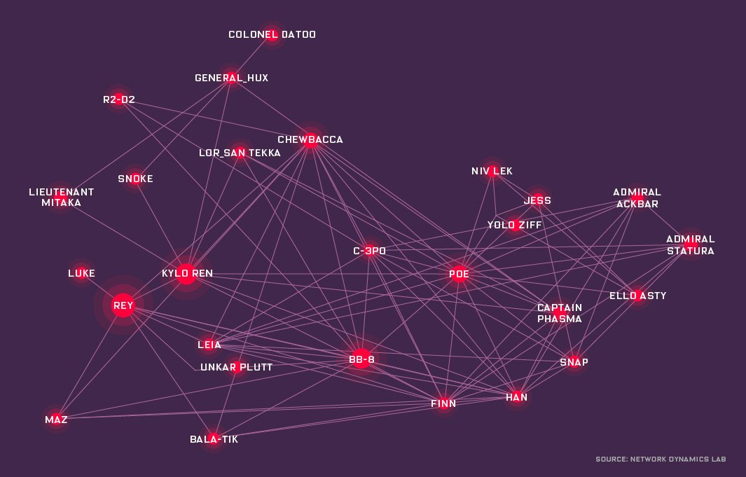

Resolution:

Plots help us find a path in the story. The points and patterns tell us many things.

Plot

Plots are simply the map of the story. There are twists, turns, holes, ups and downs. There are many plot structures, just like there are many different types of maps.

Use the plot to understand the journey of the story. This helps us theorize about the big messages/theme.