Name:
Plan of Attack!
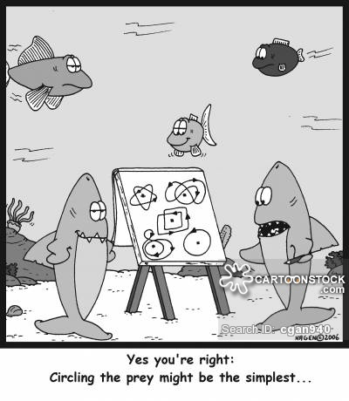

Just start typing on the document after you have saved it to your OneDrive:

Narrative:
Top Five Most Important things:

Writing Process Plan:

Argumentative/Opinion
Top Five Most Important things:

Writing Process Plan:

Explanatory/Informational:
Top Five Most Important things:

Writing Process Plan:

