Introduce myself to my partner:  Hi! My name is:  The learning target today in my own words:  I agree with my partner:  Yes, because:  No, because:  I need clarification:  This is what I will try next time: | 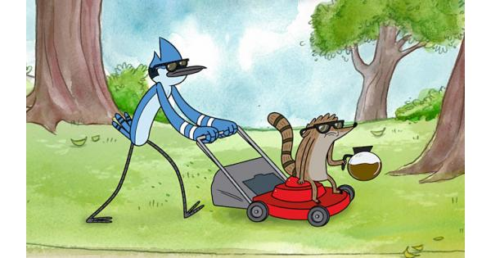  Re-introduce myself to my partner:  My name is:  The learning target today in my own words is:  I agree with my partner:  I need clarification:  This is what I will try next time: | We can introduce each other when sharing out:  “This is _____________.”  Her/his idea is:  This is what I will try next time:

This word needs clarification: | Define here with talking and sharing:
Academic Vocabulary:
- Partner: another student in the class I am working with
- Challenging or Challenge:
- Clarification: to make clear and I can understand it
- Collaboration: working together to make something
- Learning target:
- Success criteria:
- Prepared: I am ready to talk about the topic

